NodeMCU Pinout Reference
Roland April 26, 2018 Reference Leave a comment 708 Views
The NodeMCU is an Arduino-compatible board that features the ESP8266 at its core. It became popular because it is a WiFi-ready microcontroller by itself - no need for an Arduino. The aim of this article is to show all NodeMCU pinout and boards that are currently available.
Note that when programming these boards using the ESP core in Arduino IDE, the GPIO numbers are used instead of what's on the board. For example, if you would attach a LED to D7, you will refer this as 13 on the sketch

NodeMCU V0.9
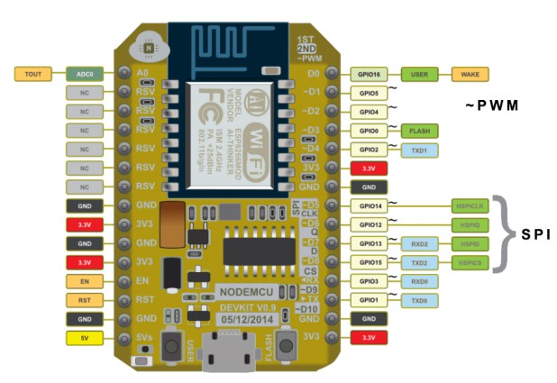
This is the first version of the NodeMCU board featuring the ESP-12. The V0.9 board has since been outdated primarily because of its width that isn't breadboard friendly. The number of Not Connected (NC) pins is also a reason.

NodeMCU V1.0
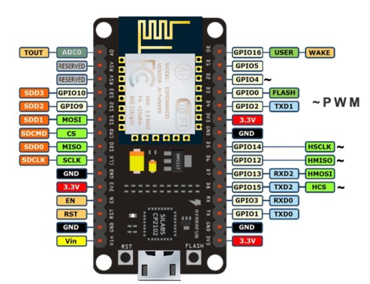
The second generation of the NodeMCU is arguably the most popular one. Amica (the company that created both V0.9 and V1.0) made this board narrower to fit a breadboard. Moreover, the ESP8266 has also been upgraded from ESP-12 to ESP-12E (a few extra pins).

NodeMCU V3
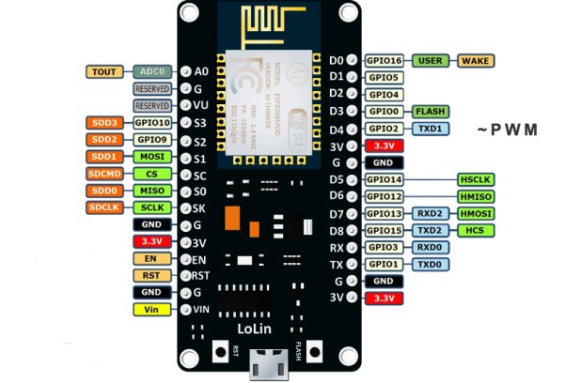
This is a version invented by Lolin with a CH340G USB-TTL chip instead of the Silabs CP2102 from V1.0. As shown, it has the same pinout structure with V1.0. But this board is slightly larger than the V1.0
These are the boards that carry the "NodeMCU" name. But they are not the only one featuring the ESP8266. See Adafruit Huzzah and WeMos D1 Mini.

============================
Retirado de: https://www.teachmemicro.com/nodemcu-pinout/

